

The Bureau of Transportation Statistics
Style Guide

Table of Contents
Branding Elements 5
Typography 6
Typeface 6
Font 6
Size 6
Line Spacing 6
Margins 6
Color Palette 7
BTS Colors 7
Use of Logos 8
Proper Usage 8
Improper Logo Usage 8
Clear Space Requirements 9
List of Logos 10
Department of Transportation (DOT) Logo 10
Bureau of Transportation Statistics (BTS) Logo 11
SafeOCS (Safe Outer Continental Shelf) 12
Bureau of Safety and Environmental Enforcement (BSEE) Logo 13
Washington Metropolitan Area Transit Authority (WMATA) Logos 14
WMATA - WMATA Labor Unions 14
Content Overview 16
Writing Style 17
Plain English 17
Audience 18
Voice and Tone 18
Word Choice 19
Instead of 19
Consider 19
Wordiness 21
Other Style Elements 22
Editorial Style 23
Document Layout and Formatting 24
Cover 24
Document Properties 24
Front Matter 25
Style & Format 26
Headings & Sub-Headings 26
Table of contents (TOC), List of Figures (LOF) & List of Tables (LOT) 27
Figures, Tables & Images 27
Bullets and Number Lists 28
Body of Report 28
Appendices 29
Final Edits 29
Website Content 30
Resources 31
508 Compliance 32
General 32
File Organization 33
File Structure 33
File Naming 34
Do use 35
Do Not Use 35
File Path in Footer 35
File Tagging Conventions 36
About tags 36
Add Tags 36
Backstage view 36
Advanced properties 36
Save as 36
6. Type tag or tag(s) separated by semicolon in tags textbox 37
7. Name file if you haven’t already and select destination to save 37
Delete tags 37
Search for tags 37
Contacts 39
Other Resources 40
Gov 40
Edu 40
Grammar Books 40
Other 41

About this Guide

The guide is organized into three sections: Branding Elements, Content Development, and Resources. It documents the Bureau of Transportation Statistics (BTS) brand and content styles to promote consistency and cohesiveness in all its publications.
- This document is for internal use.
- This document holds the brand and content styles that align with BTS guidelines.
- This document lists other relevant resources.

Branding
Chapter
1

Branding Elements
The Bureau of Transportation Statistics (BTS) uses the branding elements listed below to create a consistent voice, look, and identity for publications in each of its programs and across media platforms.
Typography
How to use the approved typefaces.
Color Palette
How to use the BTS approved publication colors.
Use of Logos
How to use logos for publications.
List of Logos
U.S. Department of Transportation (DOT) Signature
U.S. Bureau of Transportation Statistics (BTS) Logo

Typography

Typefaces & Fonts
When choosing a font for a BTS product, it should be 508 compliant. This means the font must be simple in style and easy to read. Recommended fonts for 508 compliance are:
- Times New Roman,
- Arial,
- Franklin Gothic Book,
- Veranda,
- Calibri, and
- Tahoma.

Serif fonts (like Times New Roman) are best for printed items and sans serif fonts (like Arial) are best for web viewing. Proportionally, the "ticks" and "tails" of serif fonts take up a larger amount of space on a screen than they do on a printed page. In general, it is understood that sans serif fonts display better on computers and mobile devices.
BTS publications achieve a consistent style and appearance by adhering to the guidelines below:

Size
Make fonts 12 points in all publications with few exceptions.

Line Spacing
Make spacing between the lines 1.5 points.

Margins
Give documents a 1” margin all around.

Alignment

The preferred text alignment is flush left. This is true for text as well as for tables, charts, and images.

Color Palette
BTS has a 508 compliant color palette for use across all publications. These colors have been tested with simulators to ensure that vision impaired individuals with red/green color blindness and yellow/blue colorblindness can distinguish these colors from one another when used together in an illustration. In the chart below, the main colors at 100% saturation are displayed, as well as variations on each color using different levels of opacity in the event that more than these 6 colors are needed at one time. Black and grays can also be added if more colors are needed. They are listed with the Pantone color code as well as the hex color code for ease of use.

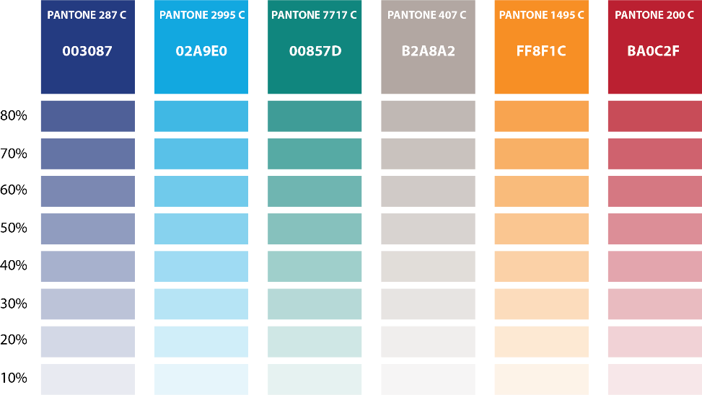

Use of Logos

DOT/BTS Signature
The primary purpose of the signature is to provide a way to consistently identify the Department and its Administrations in a clear and uniform way. All signatures are a combination of the DOT Mark (the triskelion) and the name of the Department, either by itself or with the name of a specific office. No additional elements, typography, or graphic devices should ever be added to the basic signature configuration per DOT Logo Policy.

The BTS signature consists of the mark, the Department’s name, the Operating Administration (in bold), and the Office all in the Trans typeface which is the official typeface of the DOT. All elements of the signature are placed flush left. The signature has been adopted to replace all other Department and Administration identification graphics on publications, vehicles, signage, etc. Try to avoid redundant or repeated placement of the Department or Administration names when the signature is used.

The BTS Signature should go in a prominent place on the cover of a report, or the first page of a document. Ideally the upper left-hand corner. Placement on the upper right, bottom right, or left-hand corner may be a second option if placement in the upper left portion of the page interferes with the design and layout.

Do not alter the typography, the size of the mark, or the general configuration of the signature. Use original reproduction artwork at all times. For detailed guidance on the application or use of the signature, contact the DOT Graphics & Printing coordinator for advice and counsel on unique or special applications of the signature.

The official DOT Blue is Pantone 281c, hexadecimal color code #00205B, RGB (0R, 32G, 91B), CMYK (100C, 78M, 0Y, 57K). There are 3 color options for the signature. The DOT blue triskellion with black text for most color documents, the black triskellion with black text for a black and white document, and the white triskellion and white text for dark backgrounds.

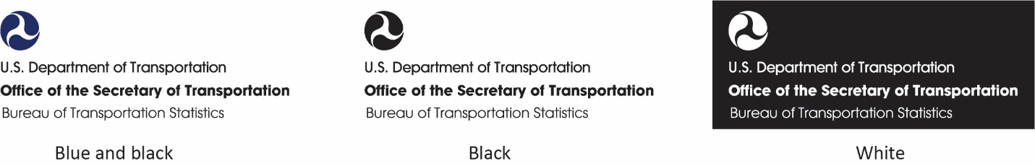

The BTS Logo
The BTS Logo is an unofficial logo for BTS and may not be used on the exterior of a report cover or document as the primary identification for BTS - the DOT/BTS signature must be used for that purpose.

The BTS logo may be used internally, in email signatures, on websites, social media, PowerPoint slides, or anywhere BTS needs to be identified secondary to the signature.
There are two versions of the logo. One with BTS spelled out with the motto “Making Transportation Count”, and a plain one with just the graphic. The logo with the motto must not be used when it is placed at a size that renders the motto unreadable. In instances when a small logo is needed, the plain logo should be used.

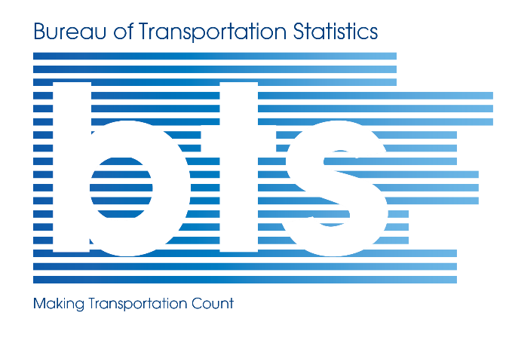


Proper Usage
- Use a high-resolution image
- Include the logo on all external communications, including brochures, stationary, business cards and websites
- Maintain integrity of logo and do not alter in any way, including adding lines, outlines or embellishments

Improper Logo Usage
- Do not distort logo
- Do not alter the proportions of the logo
- Do not tilt the logo in any direction
- Do not surround logo with other competing shapes
- Do not add shadows, effects or other elements to the logo
- Do not crop or remove any part of the logo
- Do not configure the elements into a different logo

Clear Space Requirements

Maintain the appropriate clear space on all sides to retain the integrity of the logos. There must be a minimum of 1/4 of an inch between the outside edge of the logo and any other page element, including the edge of the page.


¼”
¼”
2.5”
1”
¼”
¼”

Content
Chapter
2

Content Development
This section includes guidelines and best practices for creating content that meets OSDA’s communication goals.

Writing Style
How to write in plain English and choose the right voice, tone, and message for your audience(s).
Editorial Style
How to create content that adheres to OSDAs editorial style.
Document Layout and Formatting
How to layout and format documents.
Website Content
How to create accessible content and other best practices for creating websites and other online applications.

Writing Style

Plain English
Writing in plain language is a legal requirement for federal agencies. Agencies must use clear government communication that the public can understand and use. The Plain Writing Act of 2010 defines plain language as:
Writing that is clear, concise, well-organized, and follows other best practices appropriate to the subject or field and intended audience.
The primary goal is to keep content clear, concise, and well organized. Use Federal Plain Language Guidelines to ensure that you are creating clear and accessible content.
- Use short sentences
- Use short paragraphs
- Use everyday words
- Avoid technical jargon and if you must use it, explain it in everyday words

Audience
Start with your reader and your communication goals in mind. The purpose of your document is to communicate something to someone. What are you communicating and to whom? What is the best way to carry out your goal? Answering the questions below can help you develop a clear sense of who your audience is.
- Do you have one or multiple audiences?
- Can you segment your document to meet the needs of your various audiences, i.e., an executive summary for upper management, an appendix with detailed data for technical experts, and the body for others?
- If there are multiple audiences, can you choose one to be the primary audience?
- What is the knowledge level of your audience(s) on the subject?
- What will your audience do with the information presented?

Voice and Tone
The voice is who the readers hear talking; it is an identifiable personality, style, or point of view. The tone is the writer's attitude toward the reader and the subject. Consider the following to arrive at the right voice and tone:
- Why are you writing this document?
- Who are you writing to, and what do you want them to understand?
- What tone is right for your audience?
Strive to do the following:
- Be confident, courteous, and sincere
- Use appropriate emphasis and subordination
- Stress the benefits for the reader
- Write at an appropriate level of difficulty
- Use the active voice as it is preferable to passive voice in technical writing
"The business writer should strive for an overall tone that is confident, courteous, and sincere; that uses emphasis and subordination appropriately; that contains nondiscriminatory language; that stresses the "you" attitude; and that is written at an appropriate level of difficulty" (Ober, 1988).

Word Choice
Choose simple words where possible to increase clarity and readability. Avoid jargon, technical terms, or abbreviations that readers will not easily understand. If you must use them, explain them in simple words. Remember, the goal is to get your message across as clearly as possible. Using familiar or commonly used words and phrases help.

Instead of | Consider
- A component | - A part
- Represents | - Is
- Exhibited | - Showed
- Anticipated | - Expected
- Required | - Needed
- Frequently | - Often
- Previous | - Earlier
- Feasible | - Possible
- Accordingly | - So
- Assist / Assistance | - Aid / Help
- Implement | - Carry out / Start
- In order that | - For / So
- Utilize, Utilization | - Use

Wordiness
Less is more when it comes to writing. Look for opportunities to eliminate unnecessary words. One way to do this is to use verbs instead of nouns where possible. In general, nouns require more words to introduce them, and they tend to slow the reader down, while verbs keep things moving.
Instead of | Consider
- In the process of | - During, while
- Due to the fact that | - Although / Since / Because
- At that point in time | - Then
- Prior to | - Before
- Period of time | - Period
- Time period | - Period or time
- With the exception of | - Except for
- Be a reflection of | - Reflect
- The majority of | - Most
- By definition, these… | - These…
- Has the ability to | - Can
- All of the | - All
- Whether or not | - Whether
- A number of factors | - Several or A few

Other Style Elements
- Use a serial (Oxford) comma. Ex. I ate eggs, toast, and hash browns for breakfast.

Editorial Style

WCR Editing Sheet
- Italics: use italics for first use of a term of art. Later use should not be italicized to minimize visual noise.
- Data: is a plural noun and should take a plural verb. Ex. The data are indicative of a trend.
- Not-in-operation/in-operation: use these terms as adjectives whenever possible. Use dashes if used as an adjective before the described noun. If they must be used as a state or status do not use dashes.
- Failures/Events: use events instead of failures when possible.
- Notifications/failures/events: are used interchangeably to describe the failure notifications submitted per regulatory requirements by operators to BTS.

SPPE Editing Sheet
- Italics: use italics for first use of a term of art. Later use should not be italicized to minimize visual noise.
- Data: is a plural noun and should take a plural verb. Ex. The data are indicative of a trend.
- Wear and tear: is a singular noun.

ISD Editing Sheet

WMATA Editing Sheet

Document Layout and Formatting
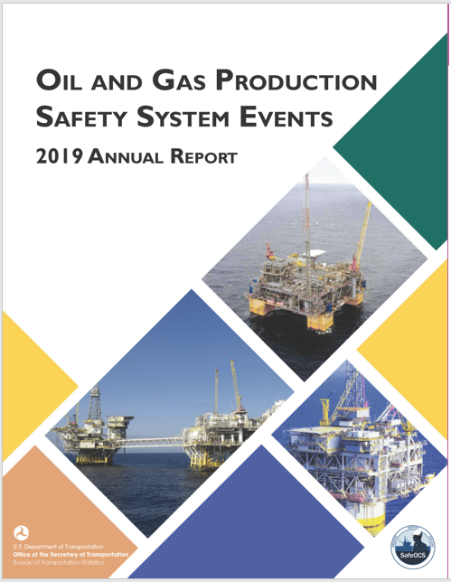

Cover
- Obtain assistance with cover design from Visual Design Specialist (Alpha Wingfield)
- List image sources in the Acknowledgments and Citation page
- Ensure that title is clear, reflects the content of the report, and contains key words that a reader might use to identify the report

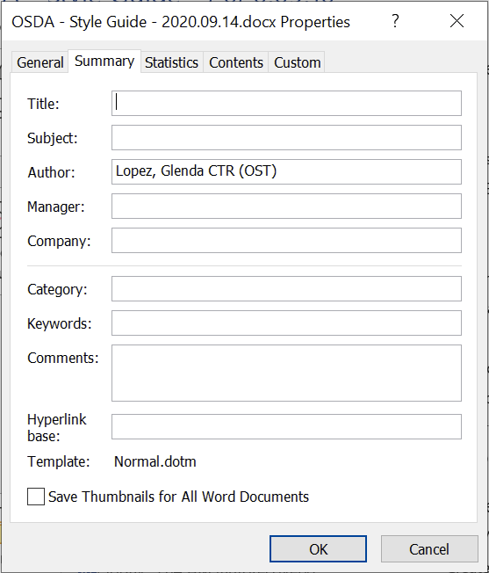
Document Properties
- Complete document properties as much as possible (File -> Properties ->Summary)
- Add keywords to make it more searchable

Front Matter
- Add a Title page, Acknowledgments and Citation page, and Quality Assurance and Notice page
- Include NTL citation with the DOI number on the Acknowledgment and Citation page.
  - Request the DOI number from the NTL before publication (contact: Leighton Christiansen)
- Insert a table of contents and update with every revision (insert -> TOC)
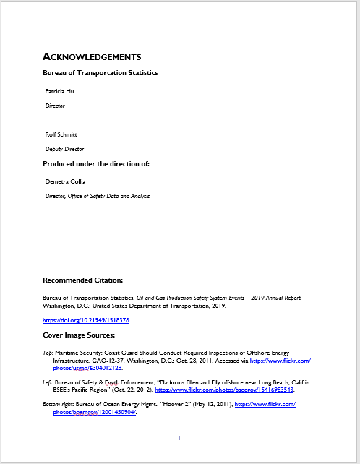
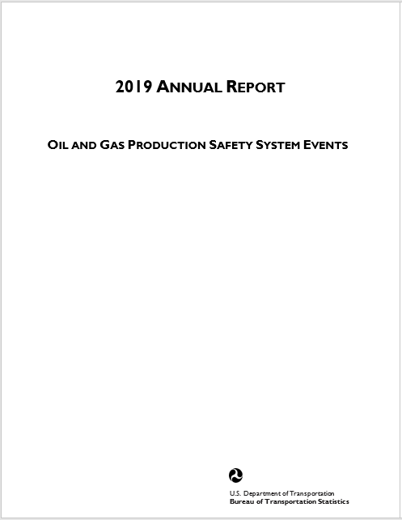

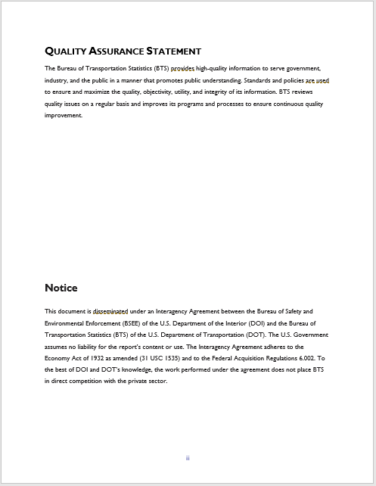
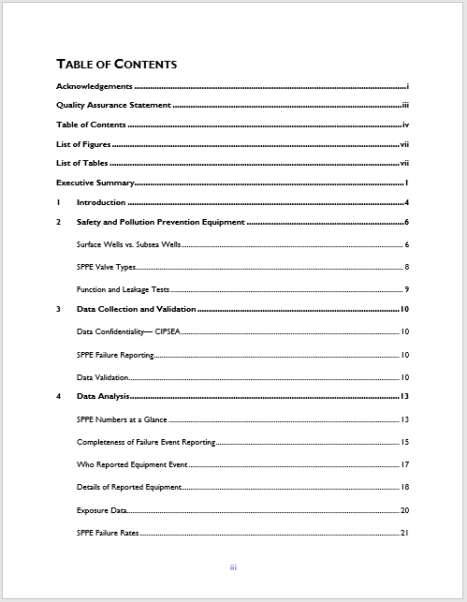

Style & Format
Use styles (home -> styles -> modify) to make editing your document easier. Set up a new document style based on an existing document or modify styles directly in the style gallery. You can format font, style, size, color, alignment, line spacing, or indentation. It is easy to use and allows you to create polished documents consistently.
- Use document styles to format a document: heading 1,2,3…; normal or body text; list or paragraphs (home -> styles)
- Be consistent with typeface, size, style, and alignment

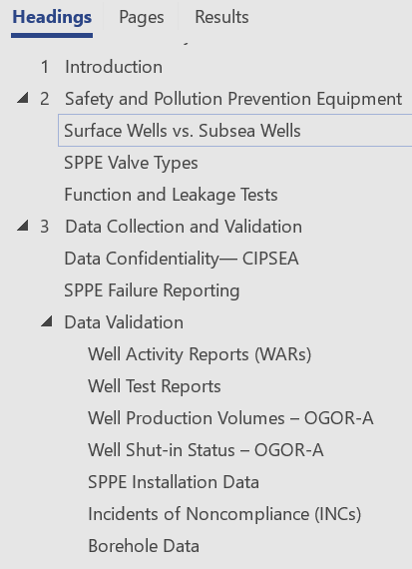
Headings & Sub-Headings
- Include enough sub(headings) to aid in reading and comprehension
- Make sub(headings) clear, informative, and consistent within the entire document
- Capitalize sub(headings) like titles using Chicago Style
  - https://capitalizemytitle.com/

Table of contents (TOC), List of Figures (LOF) & List of Tables (LOT)
- Insert a table of contents (insert -> TOC) and update with every revision (F9)
- Insert a list of figures or tables and update with every revision

Figures, Tables & Images
- Make the figures, tables, and images simple, attractive, professional, and easy to read
- Insert captions above figures, tables, and images (right-click -> insert caption)
- Make the captions clear, informative, and consistent in style and structure within the entire document
- Place the key, notes, and source(s) below the image in that order
- Left align the figure, table, and image
- Ensure that numbering conventions and decimal places are consistent within and across figures, tables, and images
- Use the same capitalization convention for labels within and across figures, tables, and images
- Be consistent with the typeface, size, style, and alignment
- Use the % symbol in tables, but spell out percent in text
- Make references in the text to figures, tables, and images easy to follow
- Insert cross-references (insert -> link -> cross-reference) so that you only have to update in one location
- Reference, explain, and interpret figures, tables, and images in the text
- Display figure and table together where it aids in understanding content
- Ensure that the list of figures and list of tables contain all items
- Indicate the units in figures and tables
- Use BTS colors in figures and tables
- Group the image, caption, source, and notes, so they move together (right-click -> group)

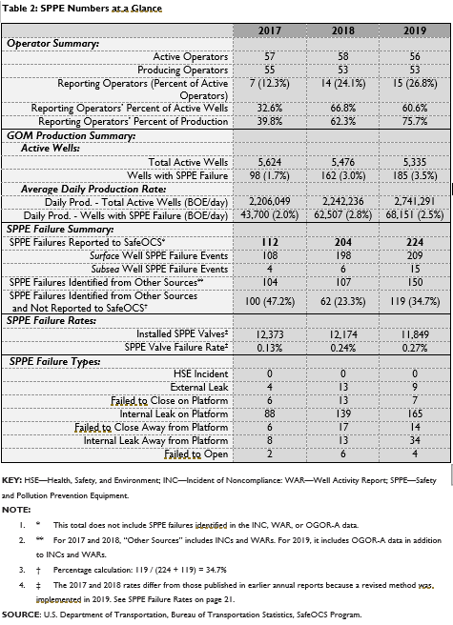



Bullets and Number Lists
- Introduce lists with a complete sentence followed by a colon
- Display bullets in order of impact or key take away
- Capitalize the first letter of each list item
- Use bullet and list styles instead of manually typed characters such as hyphens or dashes (home -> create bullet list)
- Make bullets brief and discreet and keep them about the same length as it makes reading it easier
- Make bullets parallel in structure, i.e. start with the same part of speech and maintain the same grammatical form
- Punctuate each bullet with a period if they are all complete sentences, or punctuate with all bullets with a semi-colon except for the last bullet for which you use a period

Body of Report
- Insert cross-references (insert -> link -> cross-reference) for in text references to figures, tables, and images in case their order changes
- Insert cross-references for any content that needs to be updated in multiple location, so you can update in one location
- Left align all figures, tables, and images
- Left align all text
- Add emphasis with bold or italic text, never just with color
- Numbers 1-10 should be spelled out in text. Numbers 11 and above can be written as digits.
- Use the ‘%’ symbol in tables, but spell out ‘percent’ in text
- Add page numbers and check accuracy with each revision (insert -> page numbers)

Appendices
- List appendices in the order in which they appear in the report
- Insert cross-references to appendices

Final Edits
- Remove errors introduced with track changes, i.e., double periods, comma periods, double spaces, etc. (home -> replace)
- Update table of contents, list of tables, and list of figures
- Run a spelling and grammar check (review -> ABC Spelling and Grammar)
- Leave a day or two between final edits and final read
- Check that pagination is still correct
- Remove white space in the document where possible

Website Content
Look and feel
Website content across platforms should be consistent, seamless, visually cohesive, etc.
- Drupal – content management
- Socrata -
- Tableau – data visualization

Documents
New Employee Handbook
- A link to the style guide should be included
Web posting document -Rolf
- Includes a process for posting to the web or set of requirements?

Processes
- Content Governance: controls for web content review and uploads
- Preservation
  - Preservation folder: all the content that would be needed to recreate
    - Plain text or word doc
    - File that has all images or graphs
    - Datasets that images are drawn from
    - Date that the publication/viz/etc. was posted
  - How to preserve online content
    - Leighton is working on a standard for Socrata stories
- Document versioning and file versioning

Training
- Plain Language
- 508 Compliance
- BTS Style
- Citations
  - Recommended citation which includes the DOI
    - Included on all web sites and publications
    - Eventually should be available for various styles (APA, MLA, Chicago, etc.)

Audience(s) – who will be using this content and for what purpose
Baseline Style Guide – Chicago Manual of Style
Editing Style –
Website vs. web site
And or & in headlines
Use prepositions to end sentences or not?
Headings/subheadings in sentence case or title case or all caps
Contractions – use or avoid?
Active vs. Passive voice
Numbers – spell out vs. use numerals; numbers over three digits get a comma
Email vs e-mail

Often misused words
login (noun, adjective), log in (verb)
drop-down (noun, adjective, drop down (verb)
third party (noun), third-party (adjective)

Different types of writing
Writing Technical Content
Writing Social media
Writing for Accessibility
Writing Email Newsletters

Voice
Expert but not bossy
Chapter
3

Resources
Each section includes guidelines and best practices for creating content that meets OSDA’s communication goals.

508 Compliance
How to make content 508 compliant.
File Organization
How to organize OSDA files.
File Tagging Conventions
How to add and remove tags.
Templates
Where to find available templates.
Contacts
Who to contact with questions.
Other Resources
Where to go for additional guidance.

Earlier Analysis and Structure for WCR and SPPE Reports
Description of analysis and structure for WCR and SPPE Reports. – Waiting for Amanda.

508 Compliance

General
- NTL Accessibility Checklist: https://transportation.libguides.com/accessibility/checklist
- Add emphasis with bold or italic text, never just with color
- Hyperlink and display URLs with a fully qualified URL - ex. https://www.bts.gov/
- Add alt text to the cover page and ensure that all images that compose the cover are individually identifiable - I.e., logos, and images (right-click -> edit alt text)
- Add alt text to all figures, tables, and images (right-click -> edit alt text)
- Use MS Word accessibility checker and resolve all identified issues (review -> check accessibility)
- Convert Word docs into PDFs for release and to check accessibility further
- Add document properties before running the PDF accessibility checker and complete as much as possible (file -> document properties)
- Review PDF Accessibility Checker Task List for step-by-step instructions on items below:
  - Use PDF accessibility checker and resolve issues marked with 'X' (search tools -> accessibility checker -> full check)
  - Run color contrast check manually in PDFs (edit -> preferences ->accessibility->use high contrast colors->black text on white)
  - Perform logical reading order check manually in PDFs (accessibility - > reading order)

File Organization

File Structure
Organize files in folders and subfolders by program, component, and product creating a hierarchical folder structure. The OSDA office has two programs: SafeOCS and WMATA. The SafeOCS program components are ISD, WCR, and SPPE. The WMATA program has two components: Metrorail and Metrobus. Reference the organization chart below.

Below is an example of how a folder and subfolder string might be organized.
Example 1: ISD è Company Comparison è Company X
Example 2: WCR è 2017 Annual Report

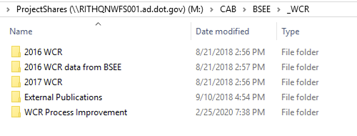

File Naming
Name all files using a logical structure such as this: program, product, type of data, analysis, yyyy.mm.dd, v 0.01, editor initials. Ex. wmata-yearly-report-data-2020-05-08-v0.01-gl. Make file names consistent, short, and descriptive.
- Use lowercase
  - Operating systems read the case in different ways
  - MS Windows automatically substitutes caps with lowercase and ignores spaces, but other operating systems (i.e., OS X, Linux) and web servers do not
- Use hyphens (-) as consistent separator (never spaces)
  - Google plays well with hyphens (not underscores)
  - Hyphens are visible when an underlined hyperlink is shown on screen (underline covers underscores)
  - Some search engines do not recognize underscores and will drop pages that have them
  - On the web, spaces in file names are replaced with %20. This makes URL (web addresses) hard to read
  - Hyphens are easier to read
- Include dates in yyyy-mm-dd format
  - This format ensures that your files stay in chronological order
- Use sequential numbering (v0.01; v2; v2.01; v3, etc.)
- Add a README.txt file in your directory that explains the naming convention and any relevant details
Do Use | Do Not Use
- Lowercase | - Uppercase
- Dashes | - Spaces / Underscore
- Include dates: yyyymmdd | - mmddyyyy
- Sequential numbering system: v0.01, v0.02, v.1 | - Non-Alphanumeric Characters (except dashes)
- Short names | - Long names

File Path in Footer
- Include the file path in the footer until document is published: ad doc info -> file path

File Tagging Conventions

About tags
Tags are custom keywords attached to Microsoft documents that help with search and organization such as words, phrases, or number strings (1.01, 2.03, 3.0, etc.) related to the file. For example, they can be project names, program names, component names, document purpose, document name, etc.

Add Tags
There are three ways to add tags as shown in the table below.
Backstage View | Advanced Properties | Save As
- Select File tab in ribbon | - Select File tab in ribbon | - Select File tab in ribbon
- Select Info tab in backstage view | - Select Info tab in backstage view | - Select Save As tab in backstage view
- Go to Properties section on far right | - Go to Properties section on far right | - Click More options below document name (if doc has been previously saved)
- Click on Add a tag | - Click on drop-down arrow to the right of the Properties heading | - Alternatively hit F12 or FN + F12 to pull up Save As window
- The text will become a text box | - Select Advanced properties from drop-down menu | - Find Tags under file name
- Add tags separated by semicolons | - Select Summary tab | - Click Add a tag
- If you separate tags by comma Windows registers entry as a single tag. | - Find Keywords | - The text will become a text box
- Save file to save tag(s) | - Enter a tag or multiple tags separated by semicolon in Keywords textbox | - Add tags separated by semicolons
 | - Select OK to finish | Type tag or tag(s) separated by semicolon in tags textbox
 | - Save file to save new tag(s) | Name file if you haven’t already and select destination to save

Delete tags
Follow these steps to delete tags. This will not work for read only or otherwise protected files.
- Select File tab
- Select Info tab in backstage view
- Delete tag(s) in Property section Tags field
- Save file to save deletions

Search for tags
Follow these steps to search for known tags:
- Click Windows key + E
- Type into the search box
  - ‘tag: name of the tag for which you want to search’
- Results will appear as you type

Follow these steps to search for unknown tags:
- Click Window Key + E to open computer
- Navigate to folder containing files you want to search
- Right-click on column heading section
- Select Tags from the drop-down menu (if tags column isn’t already displayed)
- Select the drop-down arrow to the right of Tags header (readjust column width to if you can’t see)
- Select tag(s) you want to search from available list
- Results appear as soon as you make your selection

Contacts
Visual Design – Alpha
RosaP

Other Resources
About Excel Design
- https://www.journalofaccountancy.com/issues/2017/may/how-to-design-excel-workbooks.html

Gov
- Plain Language Guidelines: https://www.plainlanguage.gov/guidelines/
- GPO Style Manual: https://www.govinfo.gov/content/pkg/GPO-STYLEMANUAL-2016/pdf/GPO-STYLEMANUAL-2016.pdf
- A Plain English Handbook: How to create clear SEC disclosure documents. https://www.sec.gov/pdf/handbook.pdf

Edu
- Purdue University: Online Writing Lab (OWL) https://owl.purdue.edu/owl/purdue_owl.html
- PennState Effective Technical Writing in the Information Age
https://www.e-education.psu.edu/styleforstudents/
- The Writing Center: University of North Carolina at Chapel Hill https://writingcenter.unc.edu/tips-and-tools/

Grammar Books
- The Elements of Style:
https://www.bartleby.com/141/

Other
- Chicago Manual of Style: https://www.chicagomanualofstyle.org/book/ed17/part2/ch05/toc.html

Plain Writing Act of 2010: https://www.govinfo.gov/content/pkg/PLAW-111publ274/pdf/PLAW-111publ274.pdf
https://employees.faa.gov/tools_resources/branding_writing/media/Writing_User_Friendlier_Documents.pdf
https://writingcenter.unc.edu/tips-and-tools/audience/
https://www.plainlanguage.gov/guidelines/words/use-simple-words-phrases/
http://phdcomics.com/comics.php?f=1531
https://libguides.princeton.edu/c.php?g=102546&p=930626
https://webtech.training.oregonstate.edu/faq/what-are-good-file-naming-conventions
https://library.stanford.edu/research/data-management-services/data-best-practices/best-practices-file-naming

